
E
scape

H

ide

T

ell

When safe to do so call Centre Management on
…………………….OR

Escape the premises
if safe to do so

IN CASE OF ARMED OFFENDER

OR

ESCAPE PLAN FOR ARMED OFFENDER INCIDENTS
Name of business and facility, address, postcode, access street, nearest cross street.

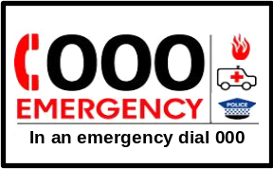

H
Meeting point address, location
MP

HIDING PLACE/REFUGE
MANUAL CALL POINT
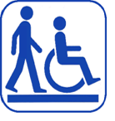

Out of sight, in silence

Validity Date
___/___/___
Mobility impaired persons
should be assisted
by a nominated person.
FIRST AID KIT
PATH OF EXIT
MEETING POINT

North
YOU ARE HERE

MP

ALTERNATIVE EXIT
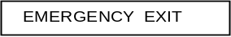
MP
H
ALTERNATE PATH

INSTRUCTIONS

This escape plan can be adapted for your store.

Under the Australian Standard AS 3745:2010 Planning for emergencies in facilities, your plan must show the following items as a minimum:
- A pictorial representation of the floor area - insert a diagram from shapes to represent the floor space.
- YOU ARE HERE location. This would show the location of the escape plan in your business. Cut and paste, or drag the icon to the location on your floor plan.
- Emergency exits and any alternative means of exit such as windows and doors to other areas. Make sure you use the icons correctly.
- Paths of travel from the escape plan to all the points of exit. The icons can be copied and lengthened for additional lines.
- Meeting point for your staff. This should be different from the emergency assembly point. If you have room, you can show this on your diagram, otherwise write the address/ location.
- Hiding places/refuge.
- Location of your store, including address postcode; access street and nearest cross street.
- Validity date [plans are valid for a maximum of 5 years].

If you are not familiar with the Word doc format, you can print it off and draw out your floorplan.

Your escape plan diagram must be A4 size if your floor space is up to 3m x 2m / 6m sq. If over this size it should be A3 size. The diagram must be oriented to show the correct direction of exit in relation to the position of the diagram and the “YOU ARE HERE” icon.

The escape plan must be placed on the wall with the bottom edge at least 120cm from the floor, and the top edge no higher than 160cms from the floor.

This escape plan is an adaptation of the standard fire evacuation plan issued by local authorities as a guide or tool for retailers.

